# **DOCUMENTATION REPORT ABOUT GENETIC ALGORITHM**

1 محمد نشأت سيد حسن 202000826

2 هناء مصطفى سعد أبو السعود 202001040

3 هالة إيهاب فهمي حنفي 202001020

4 امنية صفوت عبد الناصر 202000153

5 منى فوزي عبد الوهاب قطب 202000950

6 محمد سيد محمد صالح 201900687

**Project Idea**

The idea of the project is the act of assigning each nurse to a specific shift for each day of a scheduling horizon, while ensuring to fulfill the demand of the operating rooms (ORs) is very time consuming .

We discuss how the genetic algorithm generates multiple alternative shift plans, defined as the number of nurses required to work each shift.

The genetic algorithm, which replicates the processes within an OR wing of a hospital, uses each shift plan for an extended period of time with variable patient arrival and surgery time .

**Main functionalities**

In this project , the manager or the head make nurse scheduling which assign nurses to each shift (day shift , night shift , last night shift ) and rest days .

This scheduling also based on nurse skills level so all patients should have nursing coverage .

This scheduling must fulfill the objective of the hospital and several constraints must be satisfied .

Nurse scheduling is a timetable consisting of shifts and rest days for nurses who working in the hospital .

**Similar applications in the market**

1. Connecteam

Connecteam is an all-in-one employee management app serving industries of all shapes and sizes, including medical practices. It’s designed from the bottom up to be mobile-friendly, allowing your nursing staff to have their scheduling information in their pocket whether they’re resting at home or helping a patient .

* 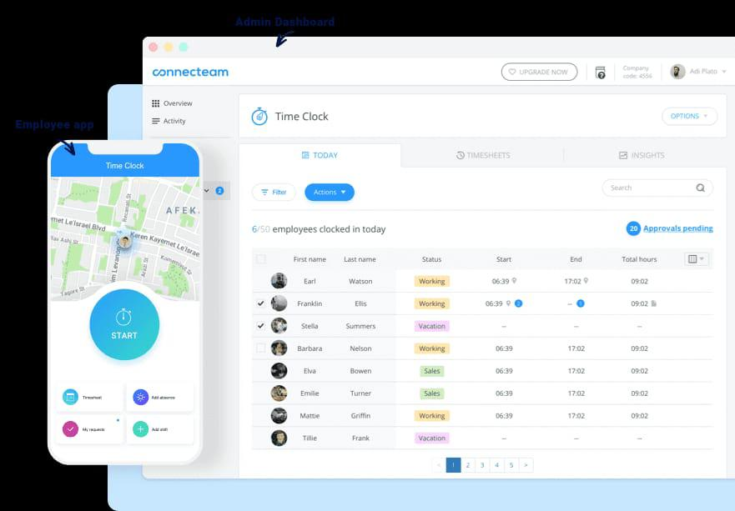

1. Schedule Anywhere

Schedule Anywhere was developed to enable teams (including nursing teams) to manage their schedules from anywhere. The software, which has been helping healthcare professionals for more than 20 years, is designed for healthcare .

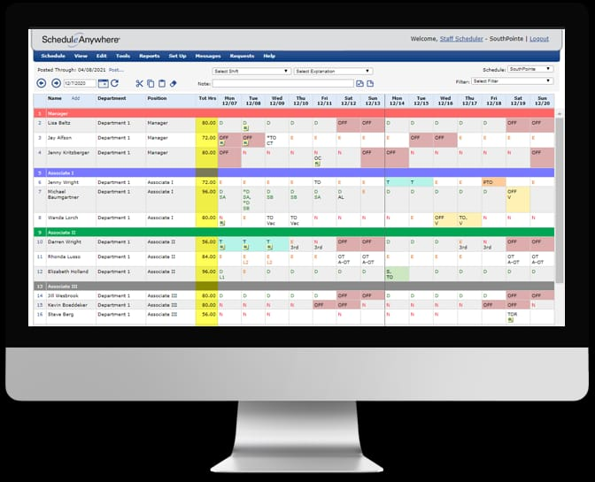

1. Schedule flex

Powered by Shift board, an open source employee scheduling software developer with more than a decade on the market, Schedule flex is specifically designed for teams that require flexible, dynamic work scheduling. Those teams include call centers, warehouse and distribution centers, and, of course, nursing teams.



1. Snap Schedule

Snap Schedule nurse scheduling software is designed to cover every aspect of modern medical scheduling, from regulatory and union requirements to overtime management.

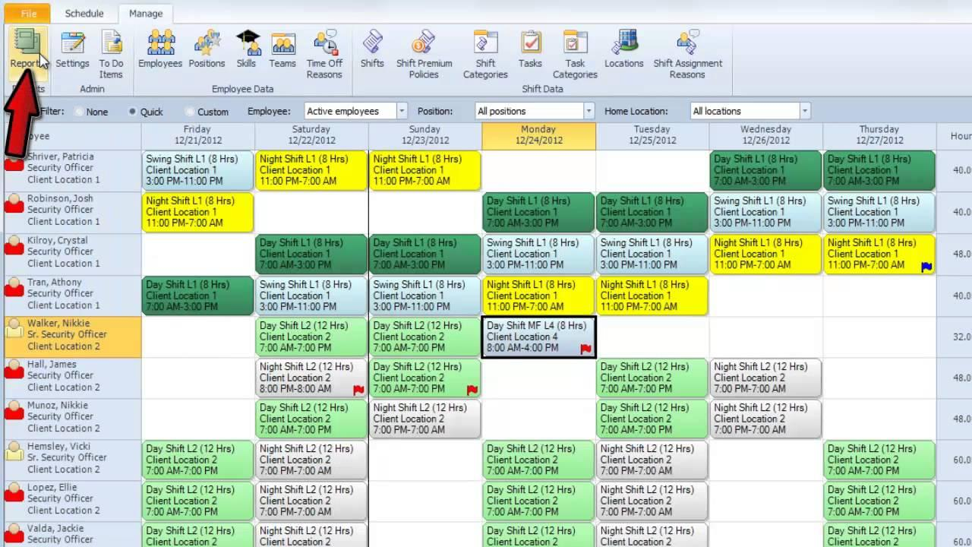

**4- literature review of academic**

**Abstract**

1-This study applied engineering techniques to develop a nurse scheduling model that, while maintaining the highest level of service, simultaneously minimized hospital-staffing costs and equitably distributed overtime pay. In the mathematical model, the objective function was the sum of the overtime payment to all nurses and the standard deviation of the total overtime payment that each nurse received. Input data distributions were analyzed in order to formulate a simulation model to determine the optimal demand for nurses that met the hospital’s service standards. To obtain the optimal nurse schedule with the number of nurses acquired from the simulation model, we proposed a genetic algorithm (GA) with two-point crossover and random mutation. After running the algorithm, we compared the expenses and number of nurses between the existing and our proposed nurse schedules. For January 2013, the nurse schedule obtained by GA could save 12% in staffing expenses per month and 13% in number of nurses when compare with the existing schedule, while more equitably distributing overtime pay between all nurses.

2-Nurse Scheduling Problems (NSP) represent a subclass of scheduling problems that are hard to solve. The goal is to find high quality shift and resource assignments, in accordance with the labor contract rules, satisfying the requirements of employees as well as the employers in health-care institutions. The Nurse Scheduling Problems (NSP) can be viewed as Constraint Satisfaction Problem (CSP) where the constraints are classified as hard and soft constraints. In this paper, a real case of a cyclic nurse Scheduling problem is introduced. This means that the generated roster can be repeated indefinitely if no further constraint is introduced. We use two different methods, namely, Simulated Annealing and Genetic Algorithm to solve this problem and compared their performances at different difficulty levels.

3-This paper describes a Genetic Algorithms (Gas) approach to a manpower-scheduling problem arising at a major UK hospital. Although Gas have been successfully used for similar problems in the past, they always had to overcome the limitations of the classical Gas paradigm in handling the conflict between objectives and constraints. The approach taken here is to use an indirect coding based on permutations of the nurses, and a heuristic decoder that builds schedules from these permutations. Computational experiments based on 52 weeks of live data are used to evaluate three different decoders with varying levels of intelligence, and four well-known crossover operators. Results are further enhanced by introducing a hybrid crossover operator and by making use of simple bounds to reduce the size of the solution space. The results reveal that the proposed algorithm is able to find high quality solutions and is both faster and more flexible than a recently published Tabu Search approach.

4-Nowadays and due to the pandemic of COVID-19, nurses are working under the highest pressure benevolently all over the world. This urgent situation can cause more fatigue for nurses who are responsible for taking care of COVID-19 patients 24 hours a day. Therefore, nurse scheduling should be modified with respect to this new situation. The purpose of the present research is to propose a new mathematical model for Nurse Scheduling Problem (NSP) considering the fatigue factor. To solve the proposed model, a hybrid Genetic Algorithm (GA) has been developed to provide a nurse schedule for all three shifts of a day. To validate the proposed approach, a randomly generated problem has been solved. In addition, to show the applicability of the proposed approach in real situations, the model has been solved for a real case study, a department in one of the hospitals in Esfahan, Iran, where COVID-19 patients are hospitalized. Consequently, a nurse schedule for May has been provided applying the proposed model, and the results approve its superiority in comparison with the manual schedule that is currently used in the department. To the best of our knowledge, it is the first study in which the proposed model takes the fatigue of nurses into account and provides a schedule based on it.

**Conclusion**

1-The findings showed that the genetic program created could manage the work schedule of nurses under given conditions and achieve the desired objective. It could create work schedules of nurses that were fair in overtime payment to all the nurses and could reduce the hospital expenses by setting the new coming nurses’ minimum salary at 15,000 Baht per person.

2-The Nurse Scheduling Problem is a complex scheduling problem. The runtime increases as the number of variable becomes higher. Assigning proper weight to each constraints helps to get feasible solution faster. But if we assign too much weight to the hard constraints, then the solutions of good quality are hard to find. Of course, not every randomly generated problem instance has a feasible solution. When no weight it assigned to the constraints it is quite possible that some of the problems do not have feasible solutions. In this paper, we applied Simulated Annealing and Genetic Algorithm for solving Nurse Scheduling Problem which was modeled as weighted CSP. In most of the cases our programs were able to return a feasible solution satisfying the hard constraints. But the SA implementation proved to be more useful than GA. What is more interesting is that the resulting roster is cyclic, i.e. the same roster can be repeated after the given duration.

4-Scheduling work shifts in many industry and service occupations directly affects the mental and physical health of employees. This matter can be more obvious in occupations like nursing where employees are usually working under high pressure and stress. Therefore, it would be better to consider employees’ satisfaction and convenience in providing scheduling so that work hours impose lower pressure on them.

During the last months and due to the pandemic of COVID-19, physicians, nurses, and other persons in hospitals across the world are working under the highest pressure benevolently to suppress this insidious disease. This urgent situation can cause more fatigue for these persons, especially for nurses who are caring for COVID-19 patients 24 hours a day. Therefore, nurse scheduling should be modified with respect to this new situation.

In this paper, a mathematical model has been proposed to optimize the work shift of nurses considering human factors. To do so, according to experts’ points of view, fatigue as the most important factor among human factors has been selected, and minimizing fatigue by creating different time intervals of rest during shift works has been addressed.

To solve the proposed model, a hybrid GA algorithm has been performed. In addition, to validate the efficiency of the proposed model, real data from the department of COVID-19 patients in one of the hospitals in Esfahan have been used where scheduling is currently determined manually. In fact, applying the proposed procedure of this paper, a timetable for all shifts of this department has been provided for May, and results have been compared with those currently used in the considered department and provided manually. Results approve that while the proposed approach imposes a little more cost to the department, it outperforms the current manual scheduling in both fatigue factor and time of providing a time table.

Apart from the lower required time for providing a timetable compared with the former manual approach, one of the main advantages of the proposed approach is eliminating personal tastes. It has been done because in the proposed approach, no one is involved in providing schedules, and the level of available resources is the only effective factor on the final schedule. To sum up, the proposed approach distributes nurses within the shifts in a fair manner considering the least fatigue while the required time for providing a schedule is significantly lower than the manual approach as well. However, another strength of our proposed approach is its generalizability. In other words, due to the structure of formulation, the proposed model could be used in either other healthcare departments or other continuous systems where a schedule for different shifts is required. In all of these settings, the model could distribute nurses/workforces within different shifts fairly considering least fatigue.

In future research, our model can be developed by considering other human factors such as rewards, motivation, and loyalty. Also, developing other heuristic and metaheuristic techniques would be an interesting direction for future research.

References

1-https://www.hindawi.com/journals/mpe/2014/246543

2-

<https://www.iaeng.org/publication/IMECS2008/IMECS2008_pp96-100.pdf>

3-

<https://www.sciencedirect.com/science/article/abs/pii/S0305054803000340>

4-

https://www.hindawi.com/journals/jhe/2021/5563651/

**Details about Genetic algorithm**

Genetic algorithm can optimize which means find better solutions not new solutions using thedefintion of solution will optimize to better one but not different one.

Most important one is that GA has a powerful ability to tackle complex problems and could be used for solving a wide variety of optimization problems with different objective functions (e.g., sta tionary or nonstationary objective functions, linear or nonlinear objective functions, etc.). Moreover, since “multiple off-springs in a population act like independent agents, the population (or any subgroup) can explore the search space in many directions simultaneously.

Next step is creating the second generation of the population based on selection processes, i.e., generation based on the selected characteristics by genetic operators.

Genetic Algorithm (GA) is one of the first Evolutionary Algorithms in which selection, crossover, and mutation are its main operators.

Is process creates a new generation of chromosomes that are different compared with the previous generation feature makes it ideal to parallelize the algorithms for implementation while different parameters and even different groups of encoded strings can be manipulated at the same time”

Due to the advantages, in this study, a hybrid GA algorithm is applied to solve the proposed NSP model.

In the selection stage, the most appropriate elements will be selected so that even the weakest elements have the chance to choose.

Connection of two chromosomes creates the child, which is added to the next generation. Process is done to find the right candidates for the answer in the next generation. Idea behind the GA originates from the Darwinian (eory of Evolutionary and, therefore, GA is categorized as a population-based algorithm.

It can be said that the GA is a programming technique that uses genetic evolution as a pattern for solving problems.is population contains a set of solutions, which represent chromosomes of individuals.

GA has a connectivity probability that is between 0.6 and 1, which indicates the probability of birth of a child, and the organisms combine with this possibility.

Full process is repeated until the last stage .

Also, Appendix B provides more detail about the applied GA algorithm.

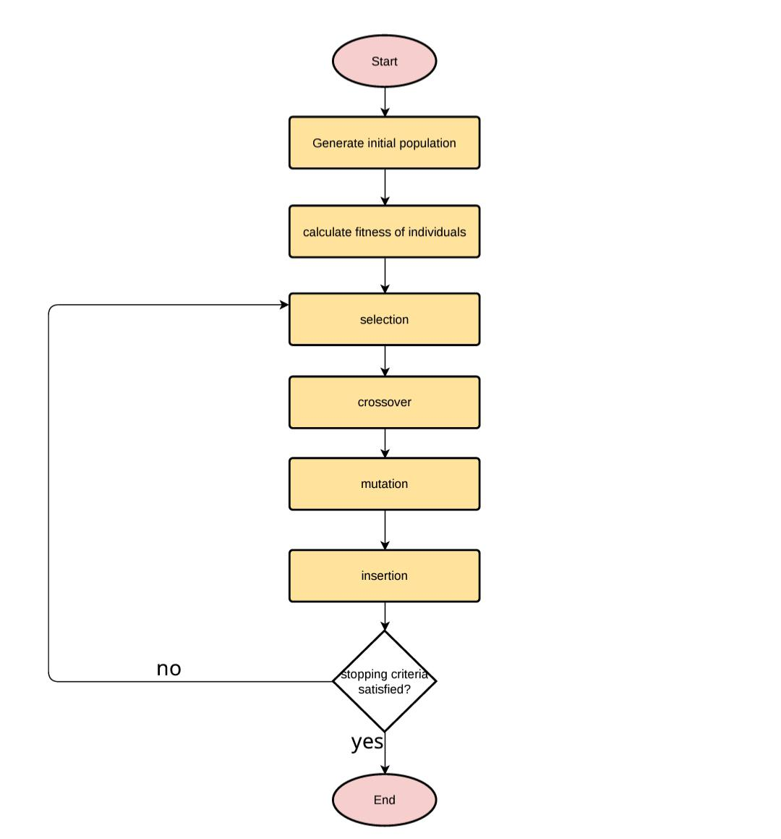

Fig.1: flowchart about genetic algorithm

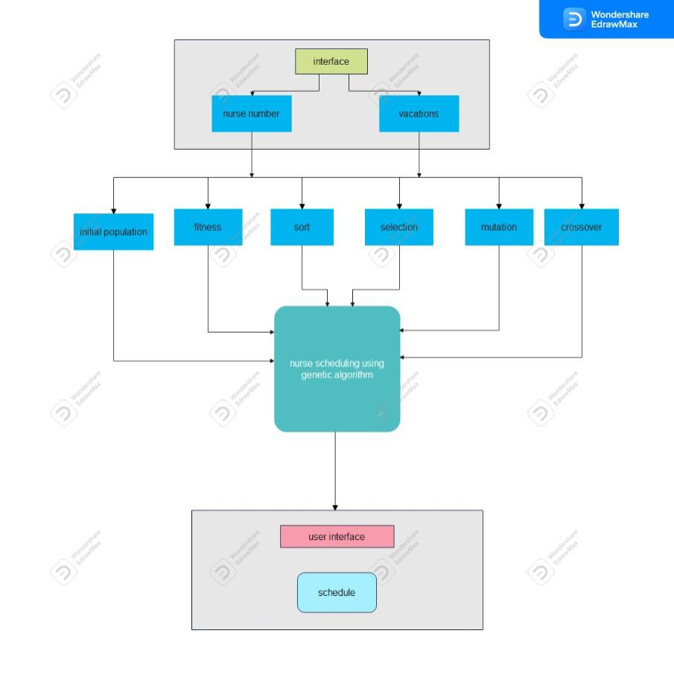

Fig.2:block diagram of genetic algorithm

***Advantages and disadvantages genetic algorithm***

The advantages

1. The concept is easy to understand.
2. GA search from a population of points, not a single point.
3. GA use payoff (objective function) information, not derivatives.
4. GA supports multi-objective optimization.
5. GA use probabilistic transition rules, not deterministic rules.
6. GA is good for “noisy” environments.
7. GA is robust w.r.t. to local minima/maxima.
8. GA is easily parallelized.
9. GA can operate on various representation.

The disadvantages

1. GA implementation is still an art.
2. GA requires less information about the problem but designing an objective function and getting the representation and operators right| can be difficult. 3. GA is computationally expensive i.e. time-consuming.

***Development platform***

* + This project work on windows and don’t need the internet – We used Microsoft Visual Studio to implement the code Microsoft Visual Studio is an integrated development environment (IDE) from Microsoft. It is used to develop computer programs, as well as websites, web apps, web services and mobile apps. Visual Studio uses Microsoft software development platforms such as Windows API, Windows Forms, Windows Presentation Foundation, Windows Store and Microsoft Silverlight. It can produce both native code and managed code. Visual Studio includes a code editor supporting IntelliSense (the code completion component) as well as code refactoring. The integrated debugger works both as a source-level debugger and a machine-level debugger. Other built-in tools include a code profiler, designer for building GUI applications, web designer, class designer, and database schema designer. It accepts plug-ins that expand the functionality at almost every level—including adding support for source control systems (like Subversion and Git) and adding new toolsets like editors and visual designers for domain-specific languages or toolsets for other aspects of the software development lifecycle (like the Azure DevOps client: Team Explorer). Visual Studio supports 36 different programming languages and allows the code editor and debugger to support (to varying degrees) nearly any programming language, provided a language-specific service exists. Built-in languages include C, C++, C++/CLI, VisualBasic.NET, C#, F#, JavaScript, TypeScript, XML, XSLT, HTML and CSS. Support for other languages such as Python, Ruby, Node.js and M among others is available via plug-ins